EXP NO: 2
CHARACTERISTICS STUDY OF SIDE BAND POWER AND FREQUENCIES IN AM USING MATLAB
Objectives:
i) To generate an Amplitude Modulated (AM) signal in MATLAB using specified carrier and modulating signal parameters.
Programming code :
matlab
clc;
clear;
close all;

% Parameters
Am = 1; % Message signal amplitude
fm = 500; % Message signal frequency (Hz)
Ac = 5; % Carrier signal amplitude
fc = 5000; % Carrier signal frequency (Hz)
fs = 20*fc; % Sampling frequency

% Time vector
t = 0:1/fs:4/fm;

% Message signal
m = Am*sin(2*pi*fm*t);

% Carrier signal
c = Ac*sin(2*pi*fc*t);

% Modulation index
mu = Am/Ac;

% AM modulated signal (DSB-FC)
am = Ac*(1 + mu*sin(2*pi*fm*t)).*sin(2*pi*fc*t);

% Demodulation using envelope detection
dem = abs(hilbert(am));
dem = dem - mean(dem);

% FFT calculation
N = length(am);
f = (-N/2:N/2-1)*(fs/N);
AM_FFT = abs(fftshift(fft(am)))/N;

% Sideband frequencies
USB = fc + fm;
LSB = fc - fm;

% Power calculations (assuming 1-ohm load)
Pc = Ac^2/2;
Psb = (mu^2*Pc)/4;

% Display results
fprintf('Modulation Index (mu) = %.2f\n', mu);
fprintf('Upper Sideband (USB) = %d Hz\n', USB);
fprintf('Lower Sideband (LSB) = %d Hz\n', LSB);
fprintf('Carrier Power = %.2f W\n', Pc);
fprintf('Power of Each Sideband = %.3f W\n', Psb);

% Plot results
figure('Name','AM Modulation and Demodulation', ...
'NumberTitle','off');

subplot(3,2,1);
plot(t,m,'b','LineWidth',1.2);
title('Message Signal');
xlabel('Time (s)');
ylabel('Amplitude');
grid on;

subplot(3,2,2);
plot(t,c,'r','LineWidth',1.2);
title('Carrier Signal');
xlabel('Time (s)');
ylabel('Amplitude');
grid on;

subplot(3,2,3);
plot(t,am,'k','LineWidth',1.2);
title('AM Modulated Signal (DSB-FC)');
xlabel('Time (s)');
ylabel('Amplitude');
grid on;

subplot(3,2,4);
plot(t,dem,'g','LineWidth',1.2);
title('Demodulated Signal');
xlabel('Time (s)');
ylabel('Amplitude');
grid on;

subplot(3,2,5);
plot(f,AM_FFT,'LineWidth',1.2);
xlim([fc-3*fm fc+3*fm]);
title('AM Frequency Spectrum');
xlabel('Frequency (Hz)');
ylabel('Magnitude');
grid on;

subplot(3,2,6);
bar([Pc Psb Psb]);
set(gca,'XTick',1:3);
set(gca,'XTickLabel',{'Carrier','USB','LSB'});
title('Carrier and Sideband Powers');
ylabel('Power (W)');
grid on;

OUTPUT:
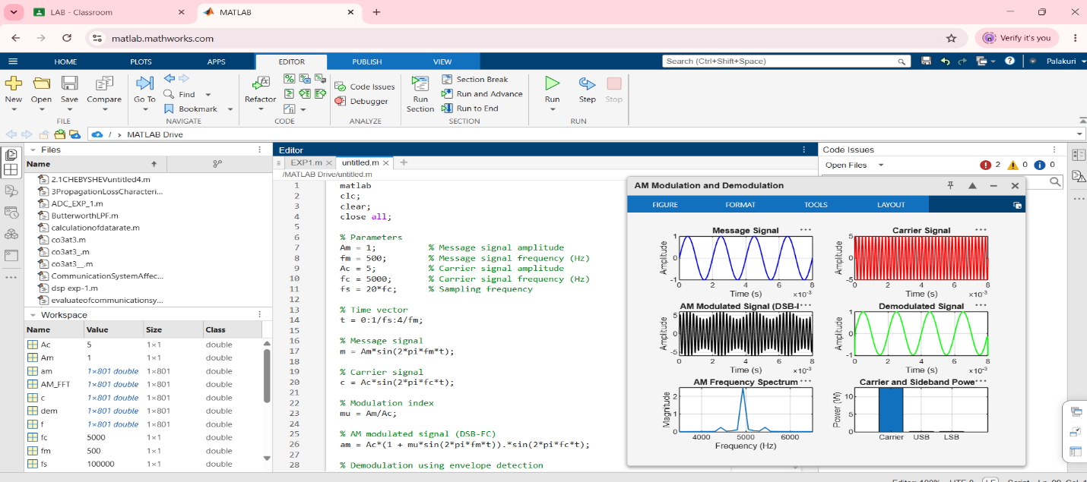
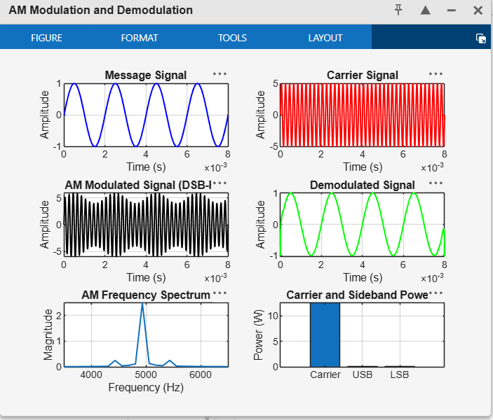
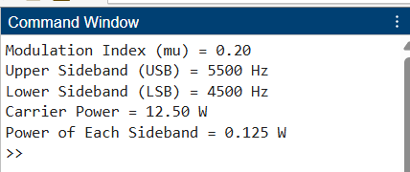

OBJECTIVE:2
ii) To determine and verify the upper sideband (USB) and lower sideband (LSB) frequencies of the AM signal using frequency spectrum analysis in MATLAB.
PROGRAMMING CODE:
clc;
clear;
close all;
% Signal parameters
Am = 1;
fm = 500;
Ac = 5;
fc = 5000;
fs = 20*fc;
% Time vector
t = 0:1/fs:4/fm;
% Generate message and carrier signals
m = Am*sin(2*pi*fm*t);
c = Ac*sin(2*pi*fc*t);
% Generate AM signal
mu = Am/Ac;
am = Ac*(1 + mu*sin(2*pi*fm*t)).*sin(2*pi*fc*t);
% FFT analysis
N = length(am);
Y = fft(am);
P = abs(fftshift(Y))/N;
f = (-floor(N/2):ceil(N/2)-1)*(fs/N);

% Calculate USB and LSB frequencies
USB = fc + fm;
LSB = fc - fm;
% Display results
fprintf('Carrier Frequency = %d Hz\n', fc);
fprintf('Message Frequency = %d Hz\n', fm);
fprintf('Upper Sideband (USB) = %d Hz\n', USB);
fprintf('Lower Sideband (LSB) = %d Hz\n', LSB);
% Plot frequency spectrum
figure;
plot(f, P, 'b', 'LineWidth', 1.2);
xlim([fc-2*fm fc+2*fm]);
xlabel('Frequency (Hz)');
ylabel('Magnitude');
title('AM Signal Frequency Spectrum');
grid on;
% Mark carrier, USB, and LSB frequencies
hold on;
xline(LSB, '--r', 'LSB = 4500 Hz');
xline(fc, '--k', 'Carrier = 5000 Hz');
xline(USB, '--g', 'USB = 5500 Hz');
hold off;

OUTPUT:
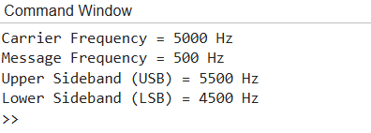
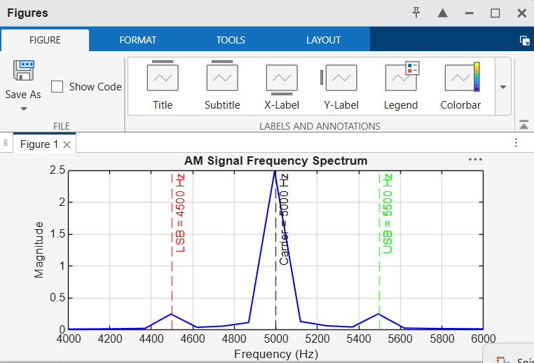
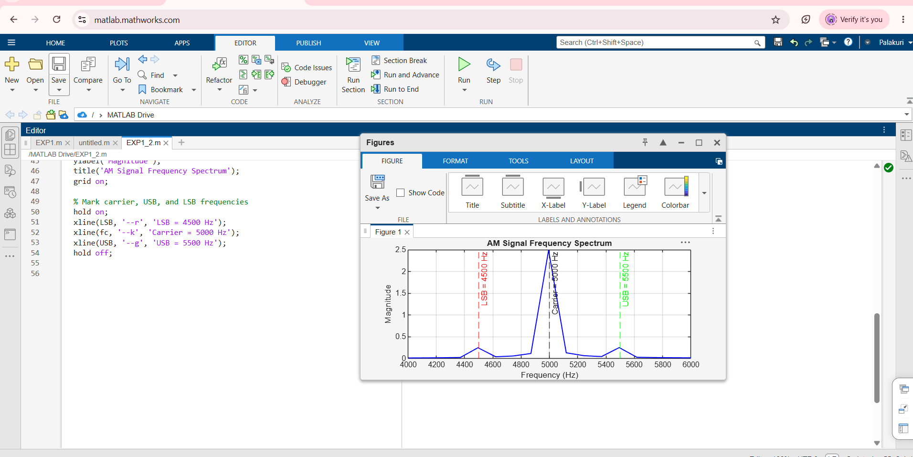
OBJECTIVE 3:
iii) To calculate the carrier power, sideband power, and total transmitted power of the AM signal for a given modulation index using MATLAB.
PROGRAMMING CODE:
clc;
clear;
close all;
% Given parameters
Ac = 5; % Carrier amplitude
mu = 0.2; % Modulation index
R = 1; % Load resistance in ohms
% Calculate carrier power
Pc = Ac^2/(2*R);
% Calculate sideband powers
P_USB = (mu^2*Pc)/4;
P_LSB = (mu^2*Pc)/4;
% Total sideband power
P_SB = P_USB + P_LSB;
% Total transmitted power
P_total = Pc + P_SB;
% Display results
fprintf('Modulation Index = %.2f\n', mu);
fprintf('Carrier Power = %.3f W\n', Pc);
fprintf('USB Power = %.3f W\n', P_USB);
fprintf('LSB Power = %.3f W\n', P_LSB);
fprintf('Total Sideband Power = %.3f W\n', P_SB);
fprintf('Total Transmitted Power = %.3f W\n', P_total);
% Plot power distribution
figure('Name','AM Power Calculation','NumberTitle','off');
power = [Pc P_USB P_LSB P_total];
labels = {'Carrier','USB','LSB','Total Power'};
bar(power);
set(gca,'XTick',1:4);
set(gca,'XTickLabel',labels);
ylabel('Power (W)');
title('AM Signal Power Distribution');
grid on;
OUTPUT:
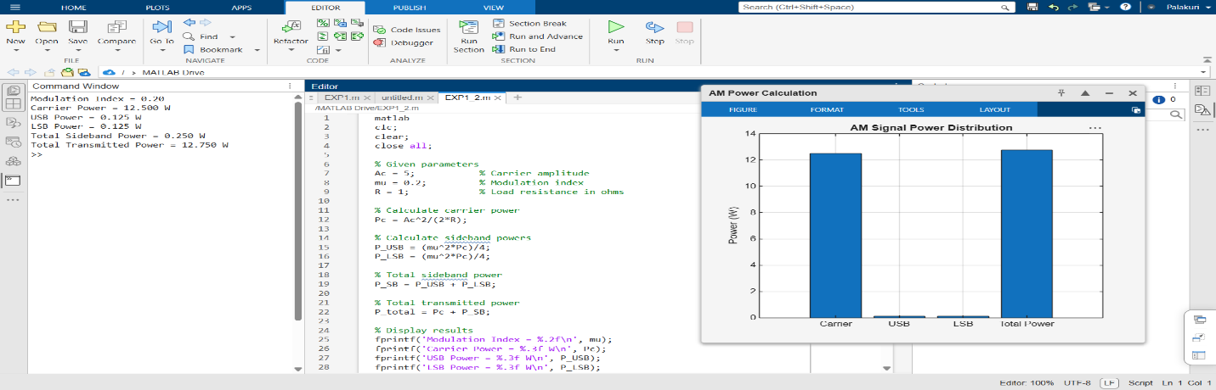
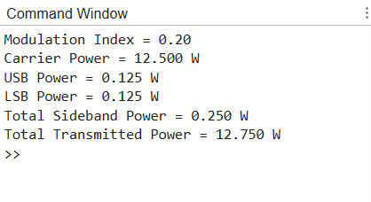
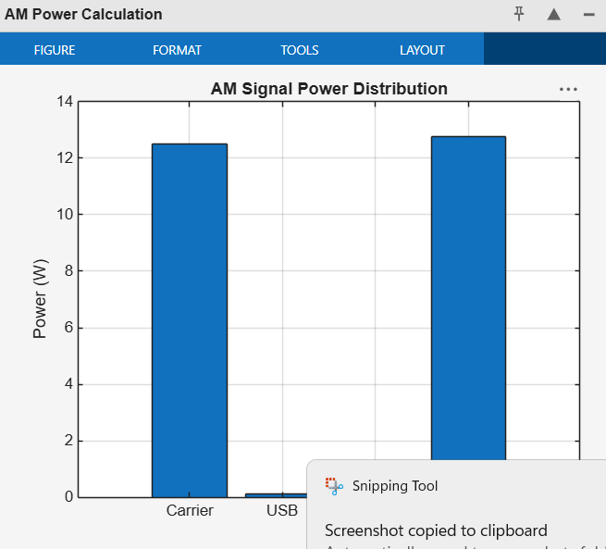
OBJECTIVE 4
iv) To analyze the effect of varying the modulation index on sideband power distribution and
overall transmission efficiency through MATLAB simulation.
PROGRAMMING CODE :
clc;
clear;
close all;
% Parameters
Ac = 5; % Carrier amplitude
R = 1; % Load resistance in ohms
mu = 0:0.1:1; % Modulation index from 0 to 1
% Carrier power
Pc = (Ac^2)/(2*R);
% Calculate sideband and total power
P_USB = (mu.^2 * Pc)/4;
P_LSB = (mu.^2 * Pc)/4;
P_SB = P_USB + P_LSB;
P_total = Pc + P_SB;
% Calculate transmission efficiency
efficiency = (P_SB ./ P_total)*100;
% Display results
fprintf(' AM Modulation Index Analysis\n');
fprintf('---------------------------------------------\n');
fprintf(' mu USB(W) LSB(W) Total SB(W) Total P(W) Efficiency(%%)\n');
fprintf('---------------------------------------------\n');
for k = 1:length(mu)
fprintf('%.1f %.3f %.3f %.3f %.3f %.2f\n', ...
mu(k), P_USB(k), P_LSB(k), P_SB(k), ...
P_total(k), efficiency(k));
end
% Plot 1: Sideband power distribution
figure('Name','Sideband Power Distribution', ...
'NumberTitle','off');
plot(mu, P_USB, '-o', 'LineWidth', 1.5);
hold on;
plot(mu, P_LSB, '-s', 'LineWidth', 1.5);
plot(mu, P_SB, '-^', 'LineWidth', 1.5);
xlabel('Modulation Index (\mu)');
ylabel('Power (W)');
title('Effect of Modulation Index on Sideband Power');
legend('USB Power','LSB Power','Total Sideband Power', ...
'Location','northwest');
grid on;
hold off;
% Plot 2: Total transmitted power
figure('Name','Total Transmitted Power', ...
'NumberTitle','off');
plot(mu, P_total, '-o', 'LineWidth', 1.5);
xlabel('Modulation Index (\mu)');
ylabel('Power (W)');
title('Modulation Index vs Total Transmitted Power');
grid on;
% Plot 3: Transmission efficiency
figure('Name','Transmission Efficiency', ...
'NumberTitle','off');
plot(mu, efficiency, '-o', 'LineWidth', 1.5);
xlabel('Modulation Index (\mu)');
ylabel('Efficiency (%)');
title('Modulation Index vs Transmission Efficiency');
grid on;
OUTPUT:
